MMC Controller SOC
Application Note

Version 0.1

Shmt Co., Ltd.

REVISION HISTORY PAGE

Issue | Rev No. | Originator | Details of Change | Date
1 | 0.1 | DJKIM | Initial Version | 2007-05-02
2
3
4
5

Technical documents for Firmware

Copyright © 2007 Shmt Limited. All rights reserved.

Confidentiality Status
This document is NOT OPEN ACCESS. The distribution is restricted to certified company.
This document is CONFIDENTIAL.

Feedback on this document
If you have any comments on this document, please contact your channel to our company.

Shmt Web address
http://www.shmt.com

Contents

1. INTRODUCTION 7
2. OverView 8
3. Test Code 9
3.1. Peripheral 9
3.1.1. DMA 9
3.1.2. NAND 9
4. Reference Application 15
4.1. SD memory 15
4.2. MMC 15
5. Performance Test 16
5.1. SD memory 16
5.2. MMC 16

Figures

[Fig - 1] NAND booting mode 시 FPGA #0 DIP Switching 10
[Fig - 2] NAND booting 시 메모리 로딩 과정 10
[Fig - 3] plane(C/G/V) on 함수 flow 14
[Fig - 4] 360x240 이미지 clipping 예제 21
[Fig - 5] Read operation flow 23
[Fig - 6] Program operation flow 24
[Fig - 7] Erase operation flow 24
[Fig - 8] Write ECC operation flow 25
[Fig - 9] 256BYTE ECC 25
[Fig - 10] 512Byte ECC 26
[Fig - 11] ECC error recovery 26

Tables

INTRODUCTION

본 문서는 MMC SOC의 reference application과 ㈜상화 마이크로텍에서 제공하는 MMC SOC의 테스트 소스에 대한 내용 및 성능 측정 결과를 다룬다.

OverView

본 장에서는 MMC SOC를 테스트하며, 성능 측정을 위해 사용된 reference application의 설명과 성능 측정에 대한 내용을 기술한다.

SMT에서 제공하는 MMC SOC의 테스트 코드에 대한 설명
NAND flash controller test code
RS(Reed Solomon) test code

Reference application 소스에 대한 설명
SD/MMC test check list를 바탕으로 한 reference application의 설명

Performance Test
SD/MMC 각 성능 테스트 사항에 대한 결과와 성능 분석

Test Code

Peripheral

테스트 코드는 NAND flash에 대한 사항으로 각 테스트 코드에 대한 내용과 소스설명을 다룬다. (Application Note에서 제외 될 지는 추후 결정)

DMA

- Top test function
DMATest()

Refer to peri/dma.c

NAND

            - Overview of Read page/Program page/Erase Block

              - Read operation flow
- Read wanted Main area of Page by Read/ReadDMA function
- Read Spare area that has get ECC information by Read/ReadDMA function.
- Get HW ECC supported form SMT NAND controller by GetECC function
- Compare HW ECC width Read ECC form NAND
- if ECC fail, you need Error recovery(Error recovery 1bit error case), other case is Fail
- if ECC OK, you can finished NAND read operation

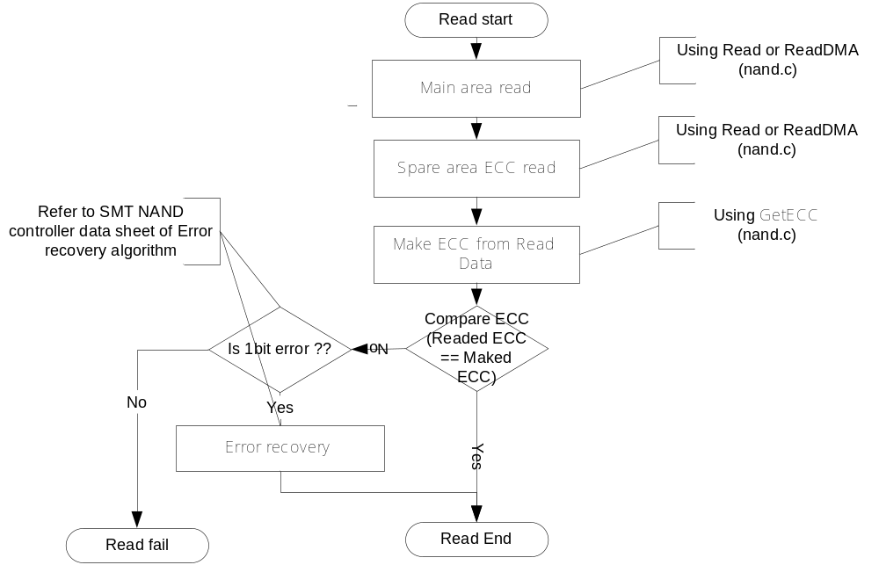
[Fig - ] Read operation flow
              - Program operation flow
- Program data wanted Main area of Page by Program/ProgramDMA function
- Get HW ECC supported form SMT NAND controller by GetECC function
- Program data to spare area relative width main area by Program/ProgramDMA function
- Program end

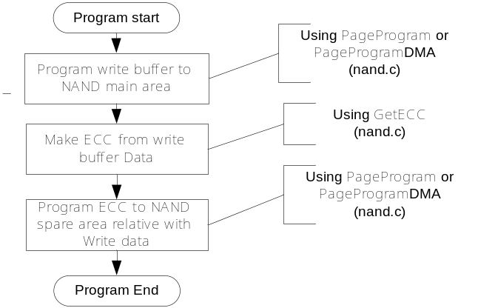
[Fig - ] Program operation flow

              - Block erase operation flow
- Select Erase block
- Call Block Erase function
- Block erase end

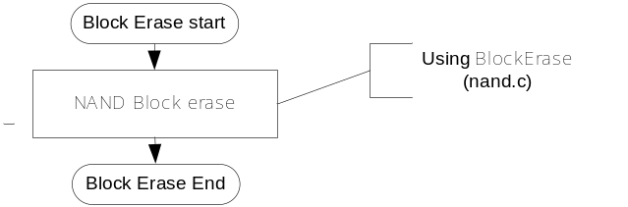
[Fig - ] Erase operation flow

              - Auto Write ECC operation flow
- make autoEccWr to true value (refer to nand.c NANDECCTest function)
- to execute and Program sequence. it function operation in Page unit, so
You use large block NAND, ECC writing per four sector, also data write per
four sector

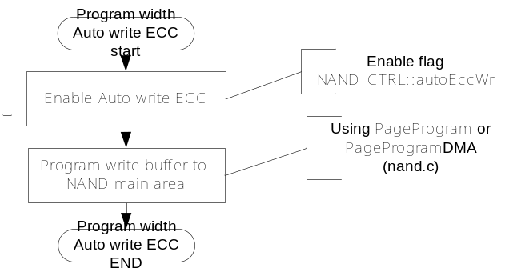
[Fig - ] Write ECC operation flow

NOTE: If you use NAND operation Read/Program/Block, You need NAND colume
/page/block address, read buffer pointer, and transfer size(default is
OPCFG_TS_WORD) and read size(wanted size to read)

            - ECC and Error recovery by ECC

              - ECC type
Our NAND controller make ECC per 256bytes or 512bytes by user input(refer to
nand.c NANDECCTest function), default is 256bytes ECC

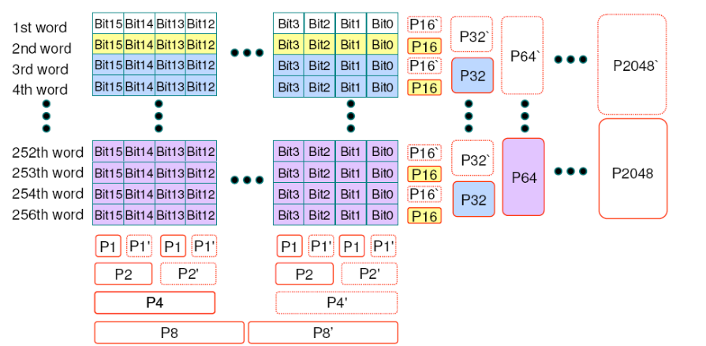
[Fig - ] 256BYTE ECC

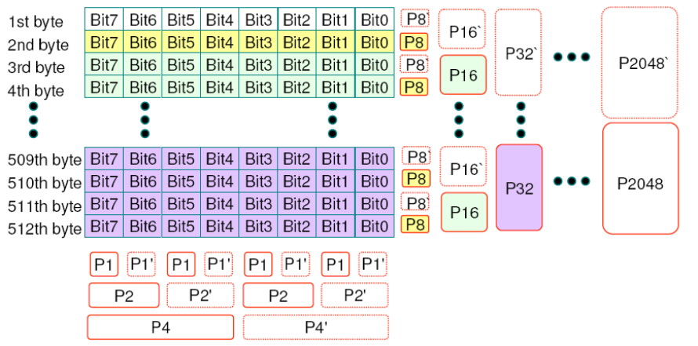
[Fig - ] 512Byte ECC

              - ECC Error recovery
We only make ECC value. So You must ECC error detect/recovery by CPU

- Get Readed ECC(stored in NAND spare area)
- Get Maked ECC(by our NAND controller)
- If 1bit difference (ReadedECC/MakedECC)is ECC error(not collectable).
- If 12bit different and Pn/Pn’(refere to above figure) is different, (ReadedECC/MakedECC)is collectable error
- (MSB)<-P4,P2,P1->(LSB) means bit error position
- (MSB)<-P1024~P8->(LSB) means byte error position
- To Recover data by ECC, You must 1 bit invert by ECC(bit/byte position).

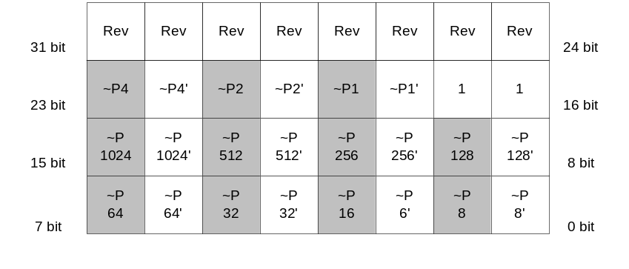
[Fig - ] ECC error recovery
            - Overview of NAND test

              - ReadID
This function get NAND specification code from NAND

              - NANDRWTest
This function Read/Write operation for SMT NAND controller validation

Category | description | Etc
RW TEST0 | Data Read/Write verify test by NAND data register | PASS
RW TEST1 | Data Read/Write verify test by system DMA | PASS
RW TEST2 | Data Read/Write verify test by NAND data FIFO interrupt(read ready, write ready) | PASS

              - NANDECCTest

Category | description | Etc
ECC TEST0 | Validation of HW ECC main/spare ECC in 256byte unit | PASS
ECC TEST1 | Validation of HW ECC main/spare ECC in 512byte unit | PASS
ECC TEST2 | Validation of HW ECC main/spare with auto write ECC in 256byte unit | PASS

- Top test function
NANDTest()
- Sub test function
NANDRWTest()
NANDECCTest()

Refer to peri/storage/nand.c
Read/write 테스트에서는 DMA/polling/interrupt 모드로 테스트를 하며, ECC테스트에서는 MAIN/SPARE/Auto write ecc를 테스트 한다.

Reference Application

SD memory

SD memory card physical test specification에 명시된 테스트를 위해 작성된 host reference application에 대해 설명한다.

1) General
General Application 함수에 대한 설명 및 소스 설명

2) Initialization
Initialization Application 함수에 대한 설명 및 소스 설명

3) Transaction
Transaction Application 함수에 대한 설명 및 소스 설명

4) Interrupt
Interrupt Application 함수에 대한 설명 및 소스 설명

5) Suspend/Resume
Suspend/Resume Application 함수에 대한 설명 및 소스 설명

MMC

MMC test specification에 명시된 테스트를 위해 작성된 host reference application에 대해 설명한다.

1)
Application 함수에 대한 설명 및 소스 설명

Performance Test

SD memory

SD memory card physical test specification에 대한 테스트 결과를 다룬다.

1) General
General test specification Result

2) Initialization
Initialization test specification Result

3) Transaction
Transaction test specification Result

4) Interrupt
Interrupt test specification Result

5) Suspend/Resume
Suspend/Resume test specification Result

MMC

The test is performed by writng/reading a 64KB chunk of data to/from random logical address.
52MHz/8bit bus
52MHz/4bit bus
26MHz/8bit bus
26MHz/4bit bus

MMC test specification이 있을 경우 SD memory와 같이 테스트 결과에 대해 다룬다.

